Function Overriding in Python
Function Overriding:
When the base class and derived class have member functions with exactly the same name, same return-type, and same arguments list, then the method in the subclass is said to override the method in the super-class.
Method overriding allows a subclass or child class to provide a specific implementation of a method that is already provided by one of its super-classes or parent classes.
- We may need to perform method overriding in the scenario where the different definition of a parent class method is needed in the child class.
- By using method overriding a class may "copy" another class, avoiding duplicated code, and at the same time enhance or customize part of it.

Following conditions must be met for overriding a function:
1. Inheritance should be there. Function overriding cannot be done within a class. We need to derive a child class from a parent class.
2. The function that is redefined in the child class should have the same signature as in the parent class i.e. same number of parameter.
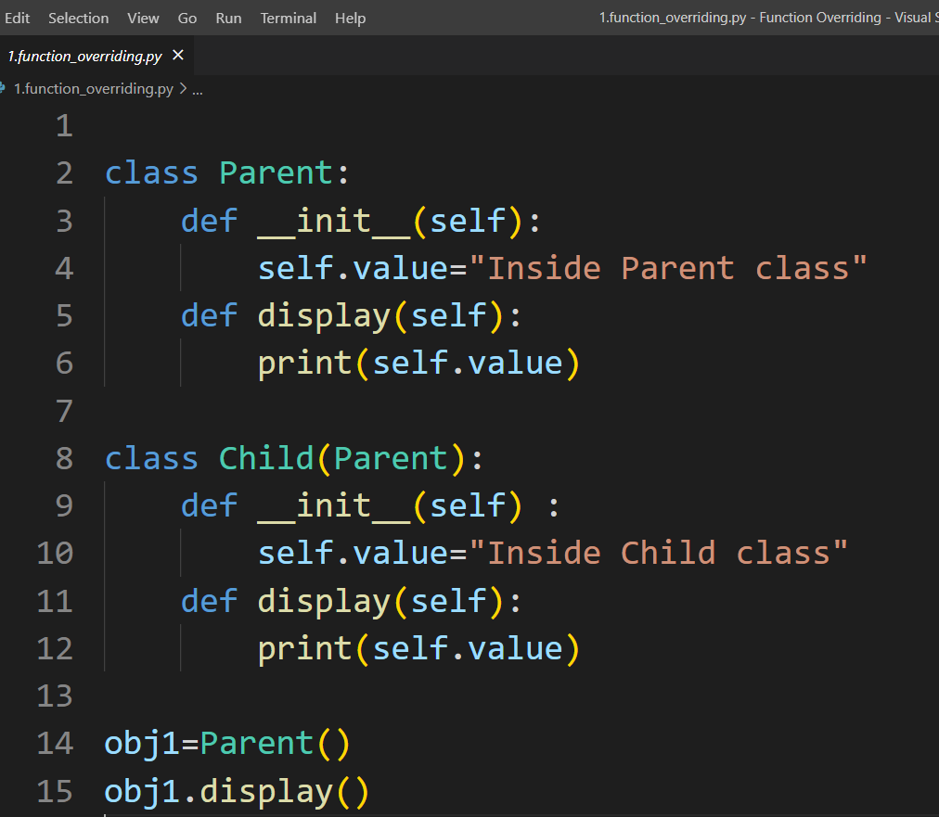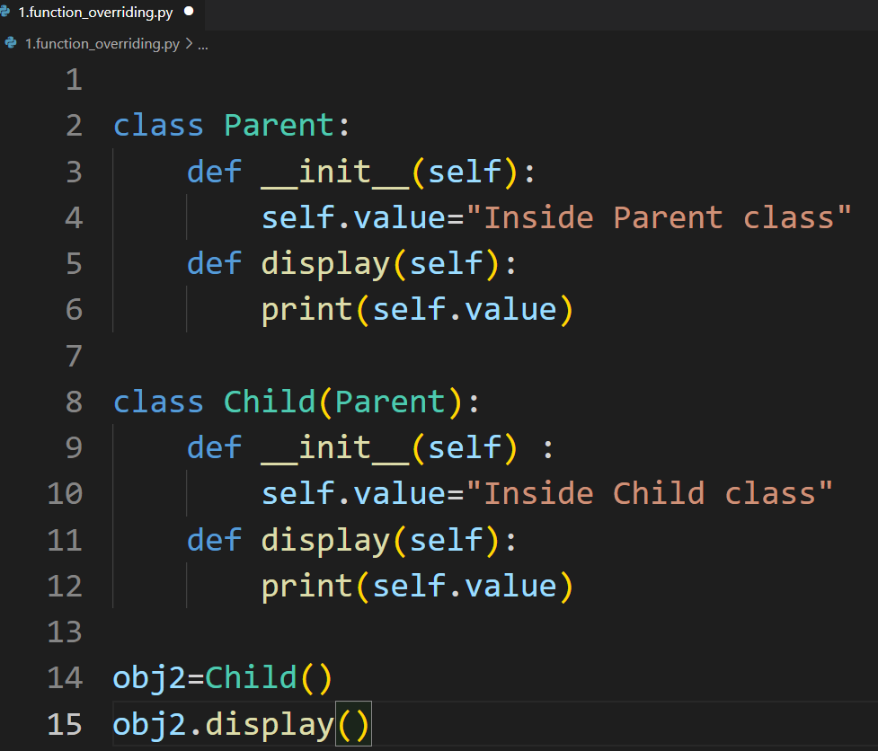
- The version of a method that is executed will be determined by the object that is used to invoke it. If an object of a parent class is used to invoke the method, then the version in the parent class will be executed, but if an object of the child is used to invoke the method, then the version in the child class will be executed.

Calling the Parent’s method within the overridden method:
Parent class methods can also be called within the overridden methods. This can generally be achieved by two ways:
- Using Parent Classname
- Using super() function

- Using Parent Classname :
Parent’s class methods can be called by using the Parent classname.method inside the overridden method.
Example:
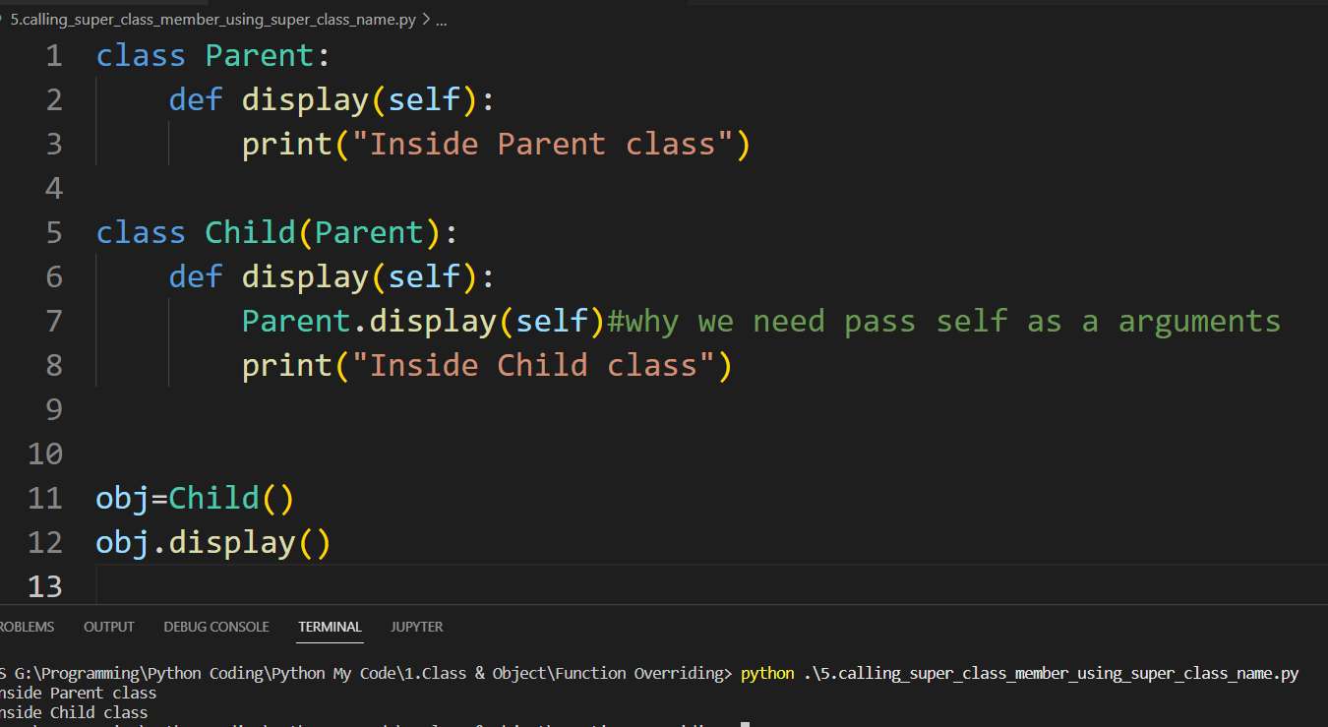

- Using super() function:
Python super() function provides us the facility to refer to the parent class explicitly. It is basically useful where we have to call superclass functions. It returns the proxy object that allows us to refer parent class by ‘super’.
Example:
